What is the meaning of courage?
Is it to fight a bull in a bullfight?
Is it to drive a formula 1 car?
Is it to fly a fighter in combat?
Is it to practice free falling parachuting
Is it bungee jumping, wild water rafting?
Is it to gamble your salary on a coin toss?
Is it to insult the doorman in a bar?
Is it to insult your boss?
Is it to go on a defective ferris wheel?
Bullshit…that is nothing…
THIS is COURAGE!!!
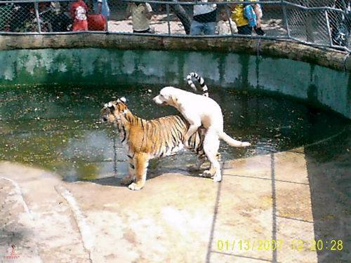
Thanx Steve

